npm run start:dev backend /api
npm run dev frontend /web
I want user name and password for login not with OTP for both buyer and seller
In create listing page need mandatory check boxes need
create listing page also for city and state dropdown should be visible for it contains overall India states and city should visible

Buyer account
8939738662
16111998
seller account
9500066201
16111998
7299632818
MachineBazaar@1
Admin
admin@machinebazaar.in
Admin@123

In applying finance page the banks will be in list with their percentage this can add by admin once they select the respective bank with percentage will trigger to admin

1.While Login to Need mandates the email and state and city
2.After approval from loan application page In Certification page need mention the name of the machine and other details for reference inspector should know which machine he is certificating
3.seller work space Buy back agreements should be move buyer work space as per flow the buyer should approve for buy back agreement.

C create
R read
U update
D delete
Operation

Need to add the Subscription module to application
1. GST verified seller can only list 2 listing application as free.
2. seller pay 1000rs they can list 4 listing in application for month valid time would be 1 month of the listing
3. once Buyer shows interest on machine Seller number will be provide once service fee paid in application the service fee would be 500 per seller contact to be view .
4.The flow would be if buyer interested with machine they can click interested the message buyer details triggered to admin also the there should be contact details will be masked once they paid clicking the payment button in same page
5.Take a reference with Kitmondo application UI and How their front page looks and how they showing machinery also need such filter there is Search by Category I need that type of filter need except broadcast ,flim and Audio also construction and agriculture capture all key words from it also while listing we need to have category as user need to select it take reference as much of it that suits our poducts and Idea
6. Also in Kitmondo application randomly can check listing they don’t need login to it but once seller want to list then it goes to login and for buyer if they click intrested request login pop will

1. Need integration with Only Razor pay with web application
2. need to add condition new machine, New less used machines , used machine , un condition

demo PIN is 1379

GIT_Repo - git@github.com:Ragava-rgv/BIM_Marketplace.git

git config --global user.name "Krishna Kanth" git config --global user.email "your_email@example.com"

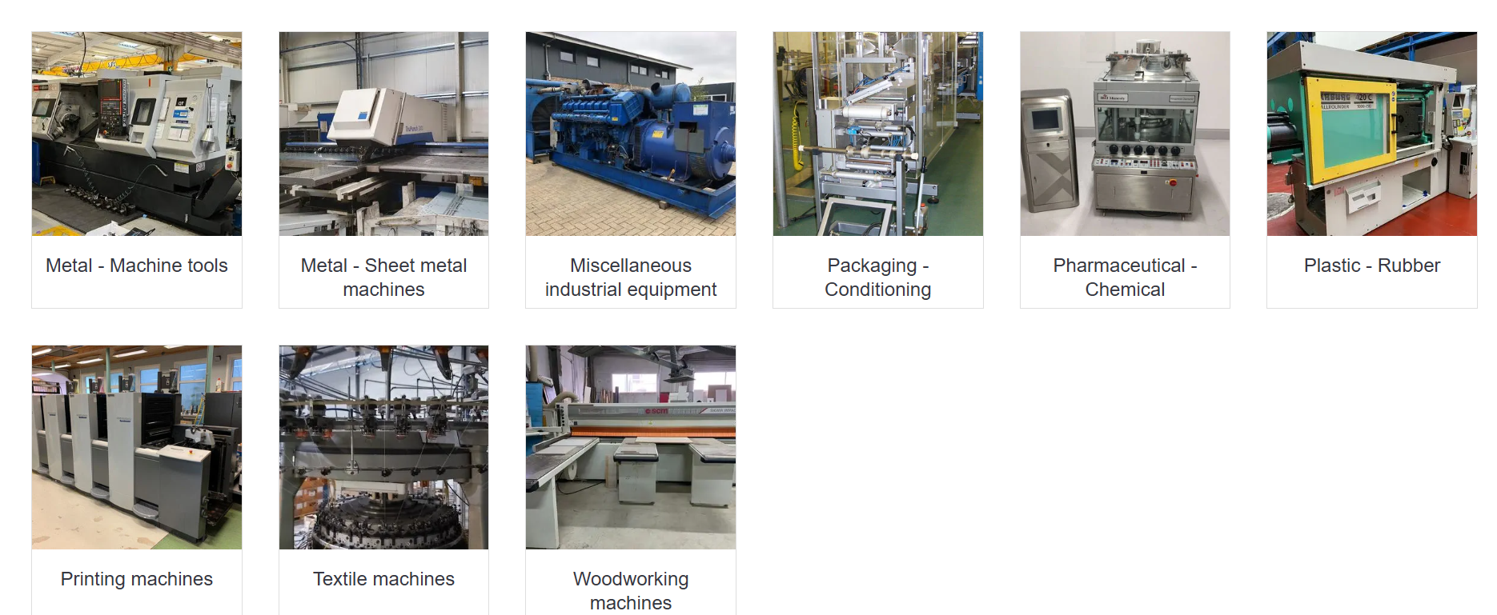

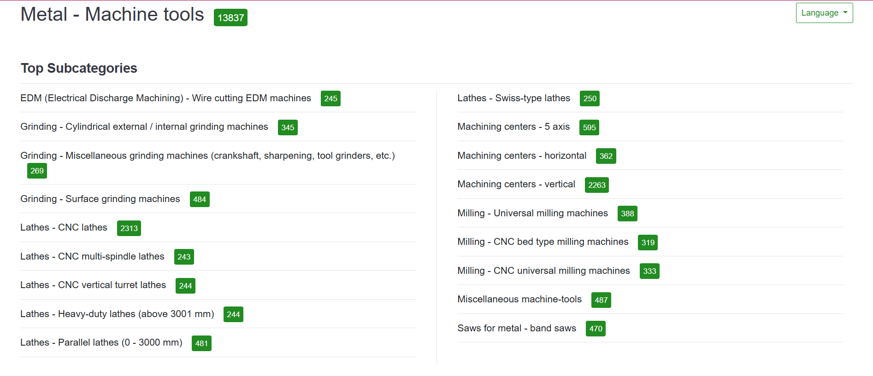

Hetzner | CX22 | 4 GB | 40 GB | ~$4.5 | ❌ (Germany/Finland)
DigitalOcean | Basic Droplet | 2 GB | 50 GB | $12 | ✅ Bangalore
Vultr | Regular | 2 GB | 55 GB | $12 | ✅ Mumbai
Linode (Akamai) | Nanode/Shared | 2 GB | 50 GB | $12 | ✅ Mumbai
AWS EC2 | t3.small | 2 GB | 20 GB EBS | ~$18–22 | ✅ Mumbai
Hostinger VPS | KVM 2 | 2 GB | 40 GB | $6 | ❌ (Eur

